# Cause: 4 day work week better than 5 day work week?

Over the course of my semester I realized how taxing working 5 days a week for hours on end can be for our physical and mental health. I wondered then, whether this had any effect on productivity as well apart from just health in professional life and not just at school. People might disagree with the idea because it would make sense that “more work hours = more work done”. However, if we take into consideration the exhaustion and fatigue that comes from 5 day work weeks, the idea that 4 day work weeks could bring not only health benefits but also productivity enhancements starts to make more sense. To dig deeper, I analyzed multiple datasets and found what follows.

Note: There are no solid legislations for a strict 4 day work-week for any country; however, cultural practices and average hours worked per week can tell us how much people actually work in those countries. To determine what countries work less, I will use data on how much people work in a year and compare countries with less hours per year to countries with more hours per year. Doing this will help keep the analysis stable because in countries like Germany and Netherlands some people might work 5-6 days a week but relatively for a very short time, making their work hours per week fall to numbers ranging from 28-35 hours per week which we consider a “4 day work week” . This is because normally people work 8-10 hours a day. Multiplying 8-10 by 4 gives us a value of 32-40 hours per week close to the number stated earlier.

In comparison, an average American works for 47 hours per week according to a gallop survey of 2014.

OR

1786 hours worked per year per person according to OECD.

## Data Collected

After analysis of an array of different datasets, I managed to find (6) dimensions that had correlations with the idea of my cause that are worth looking into. The sources are as follows:

1. <https://data.oecd.org/emp/hours-worked.htm>
2. <https://data.oecd.org/lprdty/unit-labour-costs.htm#indicator-chart>
3. <http://hdr.undp.org/en/2018-update>

I made sure that data came from trusted sources like UNDP and OECD (The Organization for Economic Co-operation and Development) found in 1961 by multiple countries for economic growth purposes.

The dimensions I looked into are: ***Year,******Hours worked****,* ***productivity (in terms of GDP/hour worked)****,* ***location****,* ***labor compensation,******and******HDI***

Countries used as examples for 4 day work weeks (countries that have worked less and least in 2018 as compared to the world):

1. Germany : 1363 Hours/year
2. Denmark: 1392 Hours/year
3. Norway: 1416 Hours/year
4. Netherlands: 1433 Hours/year

Since Germany and Iceland have similar HDI values (0.936 for Germany and 0.935 for Iceland), I thought It would be best I compare these two countries for starters and I found the graphs below.

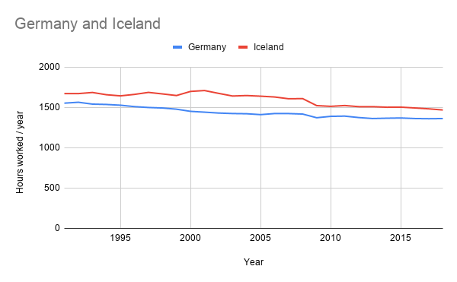

Note: GDP value is in Dollars.

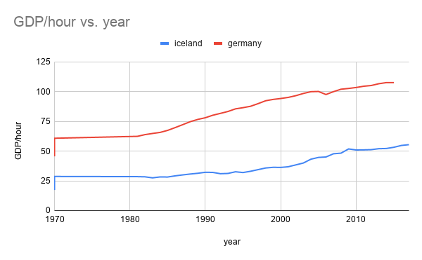

German people work less Hours/year throughout their timeline. The average productivity of German people’s work hours is above that of Icelandic people and this is one evidence for my cause. However, we have to look for more.

Similar countries were compared again as shown below. 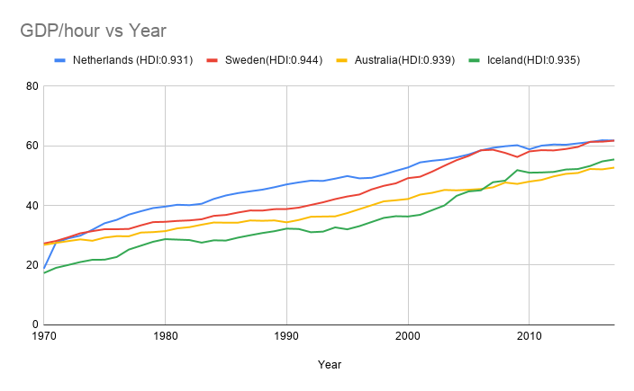

Note that all these countries are of the top 10 most developed countries of the world (according to HDI) and even though Netherlands is the last of those 10 countries, it performs better in terms of GDP per hour when compared to other countries above it on the list.

Hours worked for the same countries are as followed: 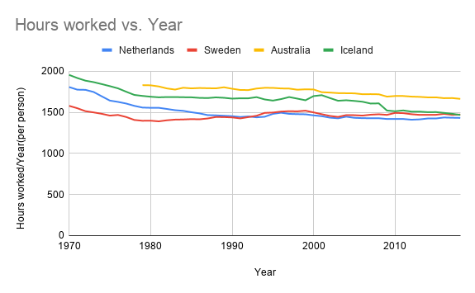

Here, we see almost the complete opposite trend. Countries that work more have less GDP yield per hour and the opposite is also true. The trends in each individual country’s line also suggests that working less would yield more GDP per hour. Of course, we need to dig deeper for more solid proof.

For further analysis, I compared the same countries for Labor Compensation (I.E wages and benefits).

According to the OECD data, “compensation of employees is the sum of gross wages and salaries and employers' social security contributions. This indicator is measured in terms of annual growth rates and indices.”

Since this indicator includes all benefits that each person receives, (I.E: wages, salaries and social security benefits), it should give us a decent overview of factors other than work hours that affect productivity. Upon analysis of the same 4 countries, I found the following graph.

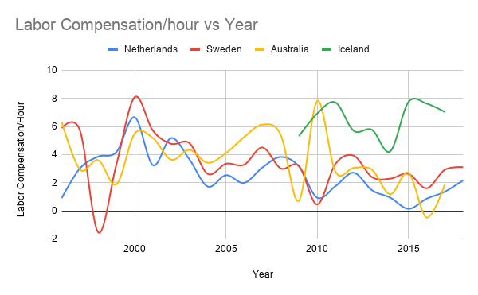

Unfortunately, the data wasn’t as “smooth” as it seems here so I had to make it smoother. The data set also didn’t have a lot of data for Iceland but I put it there anyway.

Here we can see that labor compensation doesn’t have any, or at least any obvious impact on productivity in such developed countries. When countries are this developed, it seems, one of the major contributors to average productivity per time seems to be the amount of work done.

Upon looking at the six dimensions, namely: Years, location (country), hours worked/year, productivity (the subject variable in GDP/Hours worked), Labor Compensation, and HDI (How developed the country is), it seems that the factor that effects the productivity the most is actually how much the labor works per year, since that was the only substantial correlation I found among these developed countries.

To dig even deeper, I just took a bunch of random Countries (developing and developed) and drew line charts for those countries for Hours worked and Productivity on the same graph, but with a log scale so that the comparison can be seen. This is shown below:

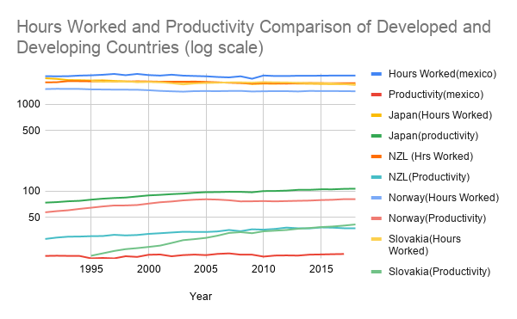

We can easily match the Hours worked and productivities of countries in this way. The countries with most hours worked (per annum) tend to be least productive (GDP per Hour). This can be seen easily with Mexico but is also seen in other countries. I.E Norway (least hours worked, second most productivity per hour). We don’t see the correlation clearly with japan because it may be an outlier. Out of these countries, japan is the only country without a military so their spending goes towards internal development which contributes to their GDP cycle and multiplier. Apart from japan, though, most of the other countries follow correlations similar to Norway, Mexico, Germany, Iceland etc.

Note: Although I had data for more than these countries, I didn’t include them in my charts because I thought it would be too messy to analyze and kept it at a minimum for easy comparison.

I could also add an additional dimension called GDP per Person (Which wasn’t in my datasets). This is the amount an average person of the country contributes to that country’s GDP and can be found easily with D3 by simply multiplying GDP per hour worked by number of hours worked per year per person of that country. This would give us more insight into the cause and tell us exactly how much more or less a person contributes per annum if he works more or less. This would be the PERFECT dimension as it summarizes the entire cause clearly and concisely, but I would need D3 to do it. (I understand why, now, we need D3 because of this and other reasons.